Importing Items into Quote/Orders/Sales Transaction

You can use an Excel file that contains product code/ Aralco Barcode in the first column and QTY in the next column. The Excel file would look like this:
Prod Code/Barcode | Quantity
100 | 15
103 | 23
10020267 | 50

Next, SAVE AS CSV (MS DOS). This will convert the Excel sheet to a Comma Separated Value (CSV) so Aralco can import it.
In the POS Transaction screen, click on functions option button “IMPORT” then on the next screen click on “Import File”. Choose “All Files” format so you can pick the CSV file which you saved.
Next you will see a screen like sample below:
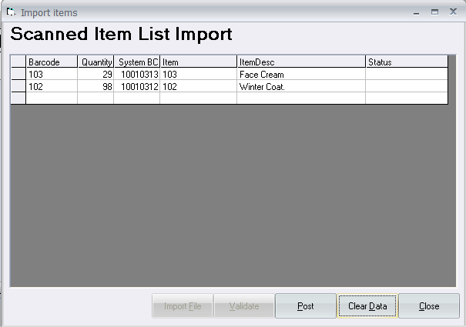
Make sure to click on:
- VALIDATE to see if any wrong barcodes were entered
- POST (to import data into the POS Transaction
- Clear Data to CANCEL
Other Import Options:
You can also import a file that contains more information such as:
- Product Code
- Item total value (e.g. Price x Qty)
- Quantity
- Remarks
- Dimension1 (e.g. Color)
- Dimension2 (e.g. Size)
- Dimension3 (e.g. Width)
- Dimension4 (e.g. Length)

The sample import file below should be laid out as shown:
Sample_Import_File.POD (you can create this file (text) and SAVE it AS, (All types) and POD Extension)
Import file should always contain the first line as shown below:
|ORDER-IMPORT|PRODCODE|TOTALVALUE|QUANTITY|REMARKS|Dim1|Dim2|Dim3|Dim4
100|70|2|#1234
101|90|3|backpacks for Alex
102|20|1|Required ASAP
1007|77|1||Black|36|C|2

Make sure there are no | and the end of any line.
Last line above is for:
- Product 1007 (Bra)
- Total Sale Value is $77.00
- Qty = 1
- Has 4 dimensions (Colour: Black, Size: 36, Cup: C, Strap Type: 2)

