**Option 1- Import Purchase Order using an Excel Sheet**

In the Excel sheet (see below sample), include:

* Column 1 – Valid Store#
* Column 2 – Valid Aralco System Barcode
* Column 3- Order Quantity

Next, in Aralco Back Office

* Go to Purchase Orders, click on NEW
* Select Supplier
* Make sure you select the store you wish to import the PO for (Single Store) OR
* If the PO is for multiple stores, select Multiple Store option shown below
* Click on the Import Scan button on the bottom right

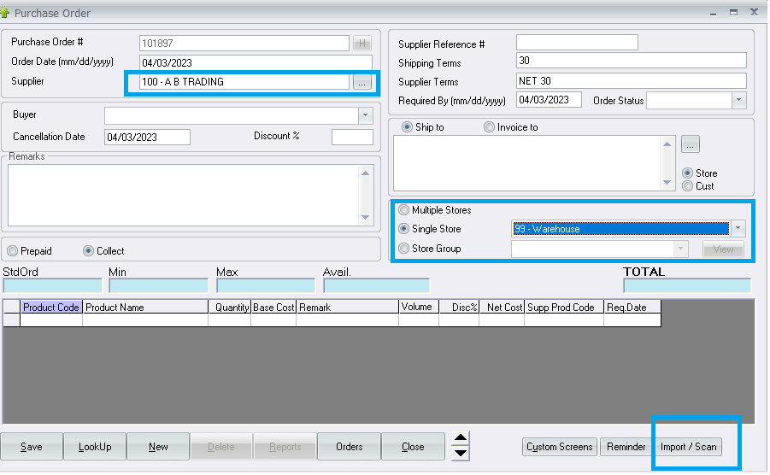

Next you will see the import option screen:

* Click on Import Excel
* Click on the Import File button
* If no issues with the imported data, you will see no entries in the “Status” column otherwise the system will inform you what the data issues are
* Next, click on POST if you approve and you will see the imported data in your Purchase Order.
* Modify and SAVE upon approval.

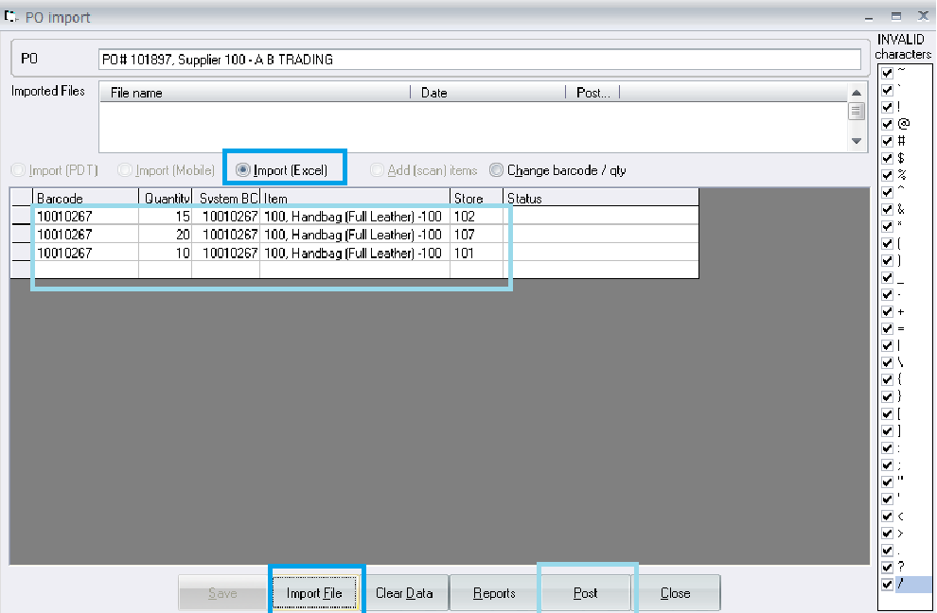

**Option 2 - Purchase Order System – PDT Import file using Excel Sheet:**

* You can import and Excel sheet with the following two columns as shown in the example below:

Barcode# Qty **<< Do not included Column labels (first row should be Barcode then Qty)**

|  |  |  |  |
| --- | --- | --- | --- |
| 233211 | | 12 | |
| 231929 | | 32 | |
| 981930 | | 23 | |
| 651931 | | 34 | |
| 491932 | | 65 | |
| 271933 | | 26 | |
| 141934 | | 27 | |
|  | |  | |

* In your Excel sheet, you have to SAVE AS and select file type as (CSV Comma Delimited) as shown below:

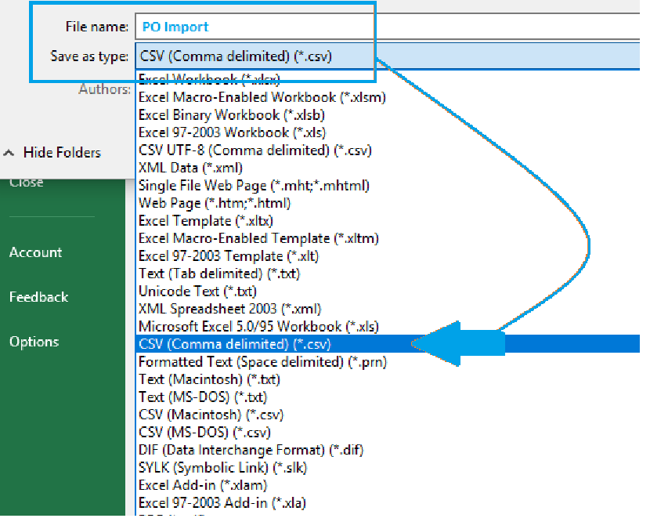

* Make sure your Excel only has the product or Manufacturer’s **barcode** and the quantity to the right of it.
* Also, make sure when you import into Aralco’s Purchase Order screen to use the DropDown option as shown below and select All Files *.*

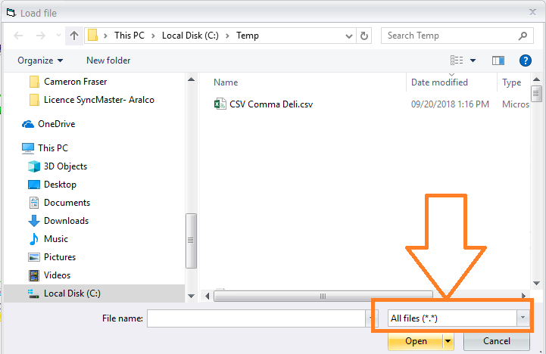

* After you import the file, any issues will show up with reasons or you can continue with a successful import into the Purchase Order.