**Physical Count Data Import via Excel**

* First make sure your count is entered into Excel with the first column including the Aralco System Barcode or Manufacturer’s barcode that is already in Aralco back office. Second column should be the quantity counted as shown below.

* Save the Excel file by clicking on “Save AS” , Name your file then select the CSV (MS DOS) format from the dropdown option. This will create a CSV file extension. Remember the folder you placed it in.
* In Aralco BOS, go to:
  + Physical Counts
  + **Lookup** the Snapshot you are counting for
  + Selected the **Store** you have counted for (dropdown on the right of the screen)
  + Click on **Display** to show all the items included in the Count
  + The Import button below the store# will now be available.
  + Click on **Import**

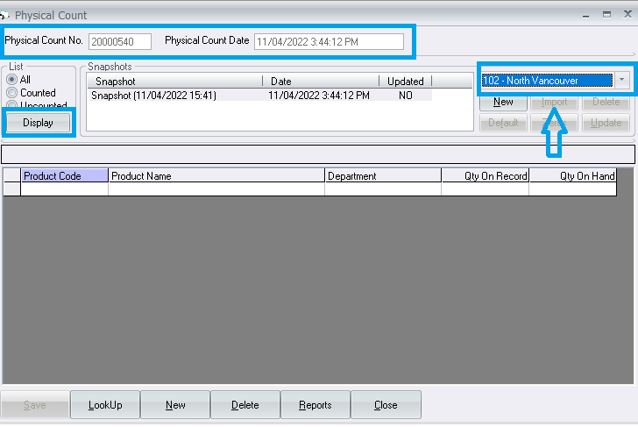

* Once you click on Import, on the next screen:
  + Make sure the **“Import (PDT)”** option is selected
  + Click on **Import**
  + Next, select the **import file (CSV)** from the folder you had saved it to
  + On the file selection form press “Select”
  + You should now see your imported items
  + Any issue with the imported products will show with comments in the Status columns as shown below.
  + Once everything is accepted, click on **POST** to push the imported data into the physical count file

