**Setting up emailing capability within the Aralco**

* **Report Generator:**
  + Go to the main screen of the Report Generator
  + Click on Settings button
  + 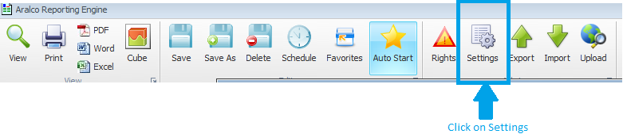
  + In this next screen, fill in your emailing credentials as shown below:

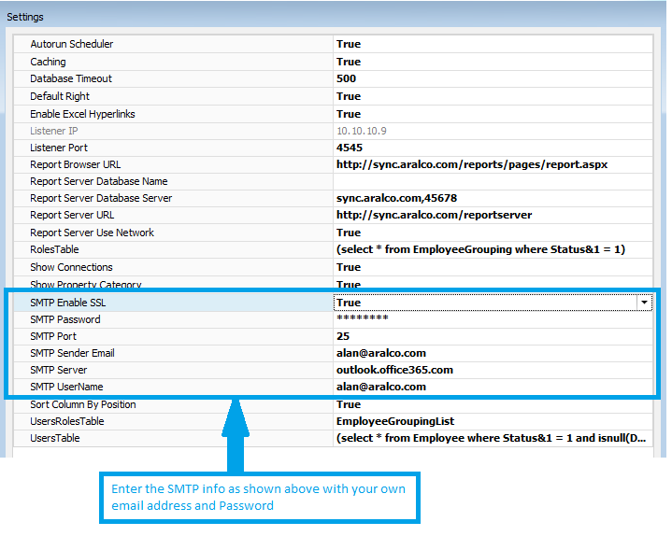

* + Click OK at the bottom of the screen. You should be able to email out of the reporting system.
* **For emailing out of the Aralco Back Office**
  + In the Back Office System, go to Utilities/ Setting
  + Go to SMTP email Settings option as shown below
  + Click on every option under the SMPT and setup as suggested below:
  + 
  + When finished, click on SAVE