**Setting up EXCEL to work with Aralco Reporting**

* Load Excel and go to FILES then OPTIONS
* Click on Trust Center
* Make sure the settings are done as shown below

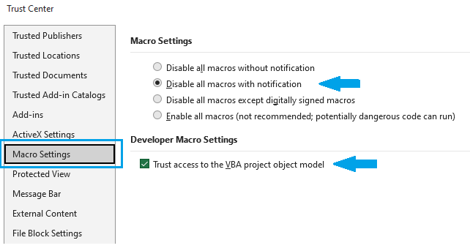

* Click OK to Save