**Please Print this document first**

**View New Features and Version Fixes on the Aralco Website**

We recommend you always view all the latest features in the new Aralco software update before proceeding with the upgrade.

To do this, you will need to login to our website with your existing **Login credentials** (email [Admin@aralco.com](mailto:Admin@aralco.com) if you do not have them) then look at the section called New Features and Version Fixes (see below):

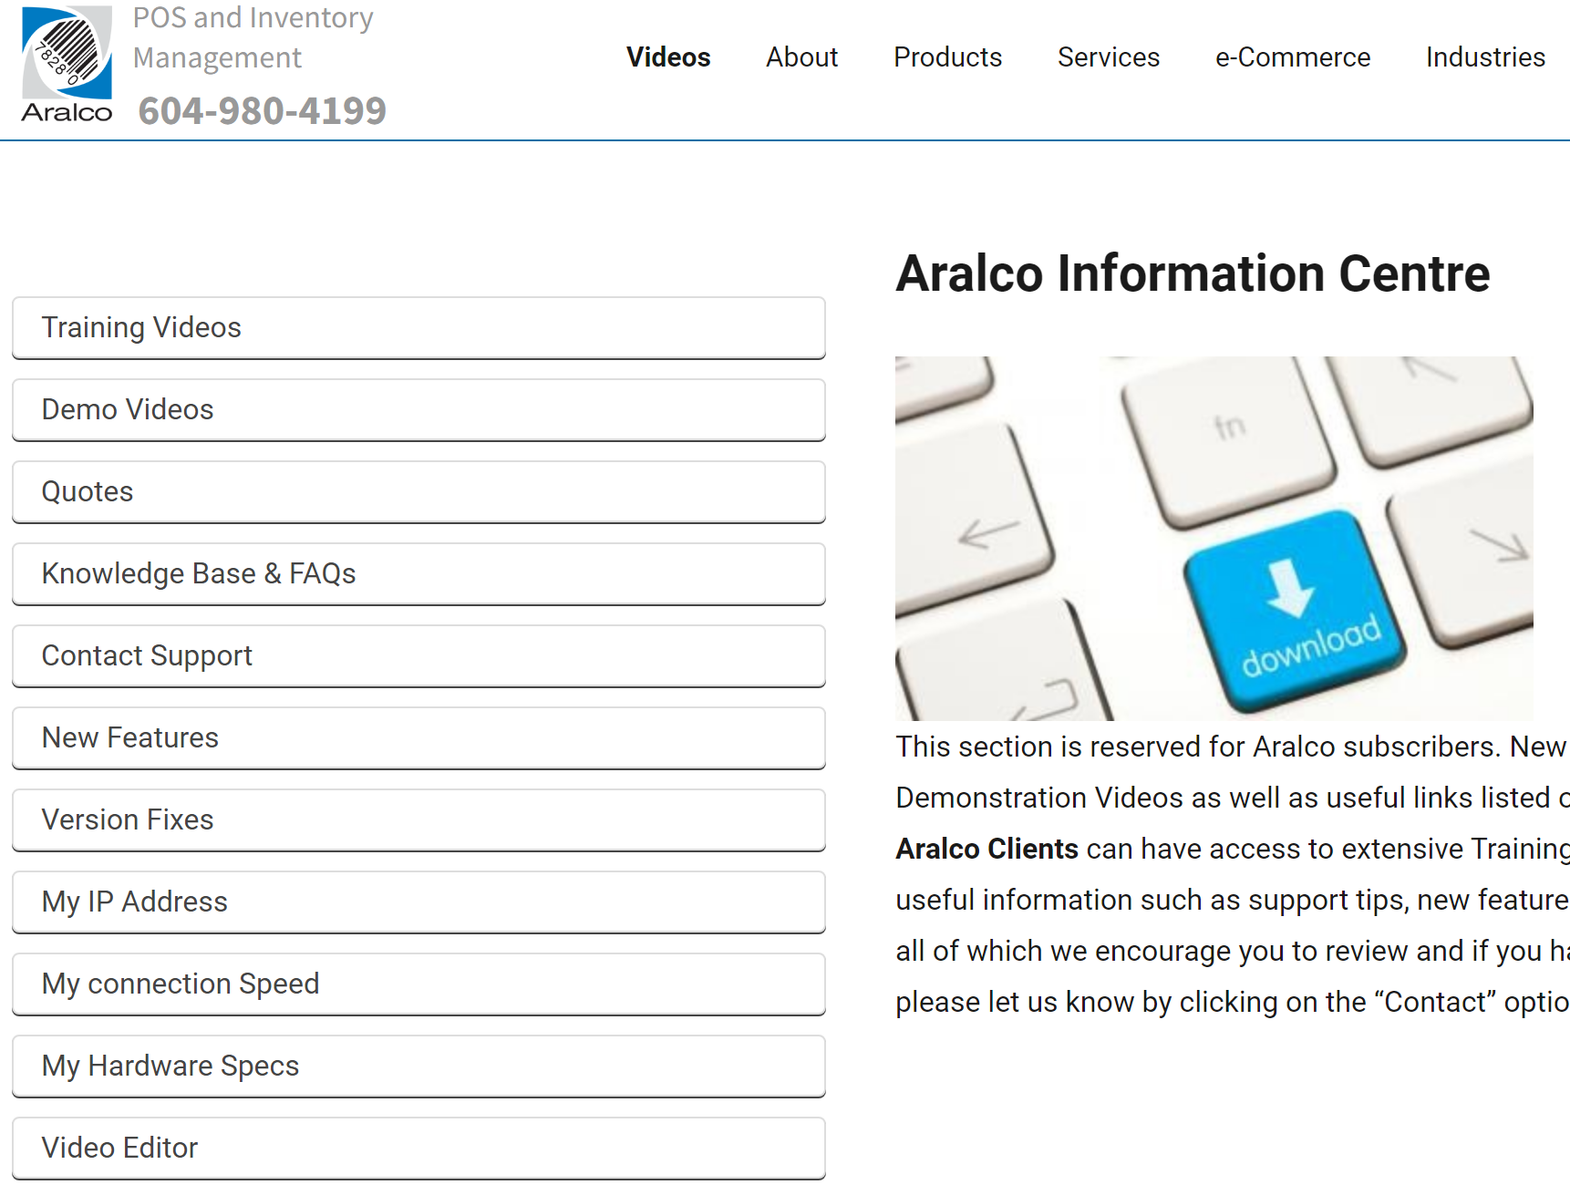

**Install Software upgrades on existing machines**

* ***Upgrades are available Monday-Thursday only***
* ***Pick a quieter time in your business especially at stores when it’s not busy as their upgrades can take 10-15 minutes depending on internet speed.***
* IMPORTANT: Always make sure your server can “see” our licence site, **sync.aralco.com**
* On the “Server” machine, go to **GOOGLE** browser and type **Sync.aralco.com**
* Enter **Install and Passkey** numbers (request this by emailing **Admin@aralco.com**) on the screen below then press **Continue**:

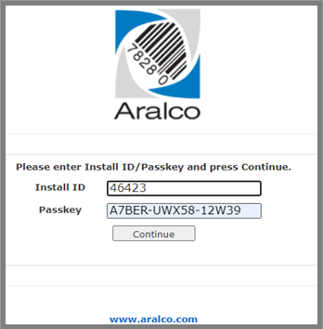

On the next screen click on “Download Upgrade Package only), as below:

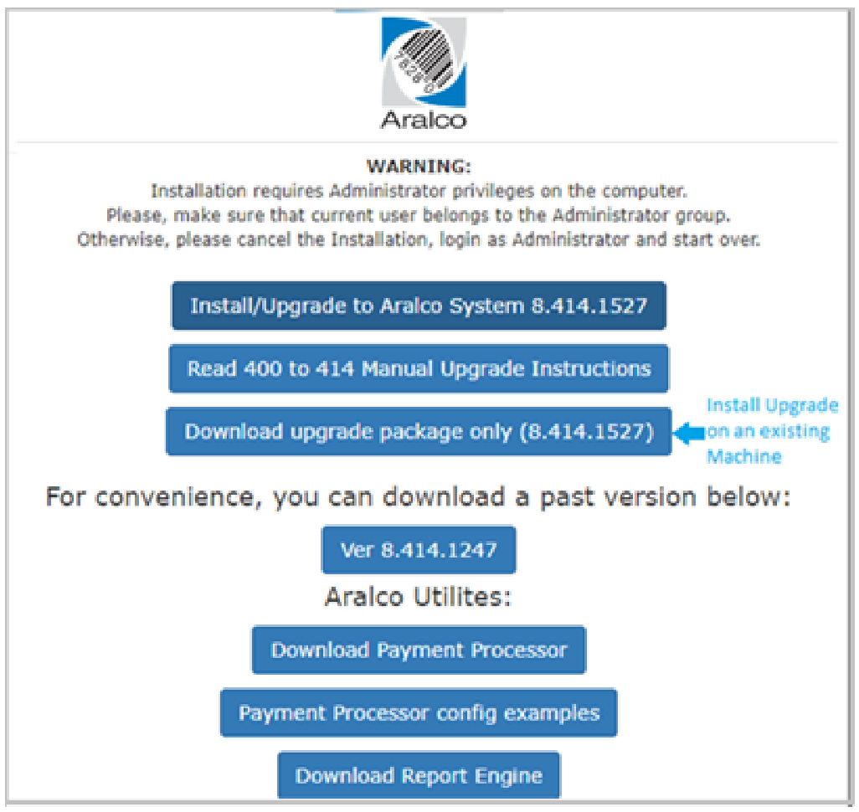

The upgrade package will be downloaded to your “Downloads” Folder on your PC

* Go to your Download folder and double click on the file PKG8….
* Click on More Info, then click on Run Anyway
* Enter the location of the package to be downloaded (Download folder is a good place)
* In that Folder, look for file **UploadCab.EXE** and click on it
* On the next screen, enter Server Name (or **IP Address**). You can find your Server IP Address by running **WhatismyIP.com** on your server
* Another way to find the server IP address is to:
  + Go to a machine that has the Aralco Back Office System (BOS) Icon on the desktop
  + Right Click on the icon then click on Open File Location
  + look for **Aralco.Ini** (CFG/Configuration file), double click on it and look for **SQL_Server_Name**.
  + Copy that address after “=” and paste into the Installation form.
  + The **SQL_DB_Name** is also in this CFG file
* Next select Database Name (**AralcoBOS** is the default)
* The update will be applied to the SQL Server
* Load Back Office (BOS) and update
* Then load POS after BOS update is done and update POS

**Install BOS/POS Software on NEW machines**

* ***Upgrades are available Monday-Thursday only***
* IMPORTANT: Always make sure your server can “see” our licence site, **sync.aralco.com**
* On the “Server” machine, go to **GOOGLE** browser and type **Sync.aralco.com**
* Enter **Install and Passkey** numbers (request this by emailing **Admin@aralco.com**) on the screen below then press **Continue**:

On the next screen click on “Install/Upgrade Aralco System, as shown below:

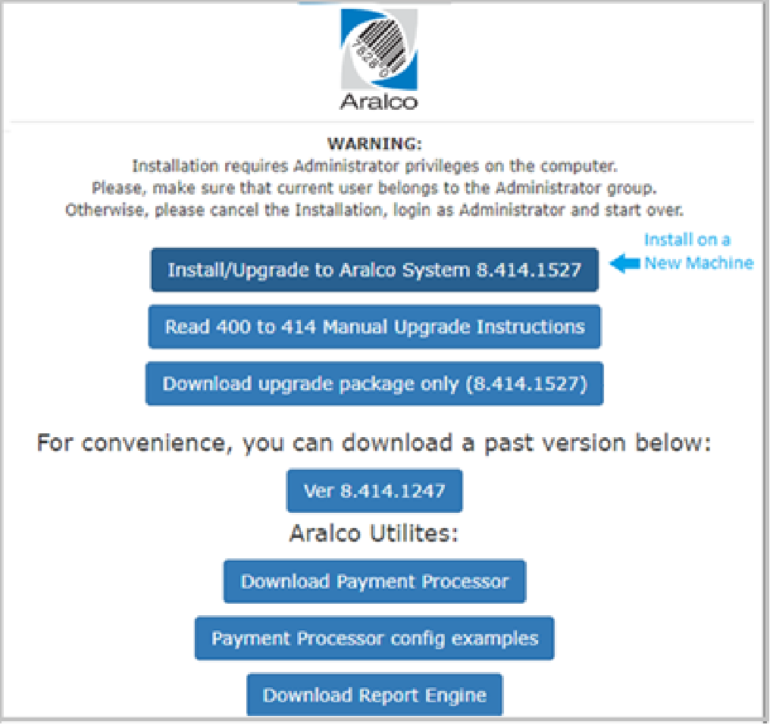

The Installation package will be downloaded to your “Downloads” Folder on your PC

* Go to your Download folder and double click on the file Aralco Setup 8.4…...
* Click on More Info, then click on Run Anyway
* On the next screen, enter Server Name (or **IP Address**). You can find your Server IP Address by running **WhatismyIP.com** on your server
* Another way to find the server IP address is to:
  + Go to a machine that has the Aralco Back Office System (BOS) Icon on the desktop
  + Right Click on the icon then click on Open File Location
  + look for **Aralco.Ini** (CFG/Configuration file), double click on it and look for **SQL_Server_Name**.
  + Copy that address after “=” and paste into the Installation form.
  + The **SQL_DB_Name** is also in this CFG file
* Next select Database Name (**AralcoBOS** is the default)
* You will next be given a screen option to Install BOS or POS or both. Make your selection and continue
* For the NEW BOS installation, you will be prompted to “Register” the new licence. Make sure you pick from available licenses and give it a useful name such as “Mary’s – Accounting” so this way you will be able to recognize the assigned licenses and can later assign them to another person/ room
* For the NEW POS installation, you will be prompted to pick from a list of Available Stores and registers then give them and assigned name such a 101-B (101 being the store# and B being the register#)
* If you have any issues with assigning NEW Licenses for BOS or POS, please contact the Aralco Support Team (support@aralco.com)

**Report Engine Installation**

* For the Report Generator Installation, click on “**Download Report Engine**”
* Wait for download completion into the “Download” folder
* Go to the computer’s Download folder, findand Right-Click on it and Run as Administrator
* Check on Desktop to see the report engine icon if not found:
* Go to this folder: **C:\Aralco\BOS\ReportEngine**

Find **Aralco.UI.Reports.EXE** and right click to “Move to Desktop”

* Click on ICON to run the Report Engine
* Setup a new connection for the client’s database access
* Login then Pin to Task Bar

**Payment Processors files download & Installation**

* For payment processor interface files, click on “**Download Payment Processor**”
* Wait for download completion into the “Download” folder
* Go to the computer’s Download folder, find and Right-Click on it and Run as Administrator
* Go back to Aralco Software Installation and click on **Payment processor Config Examples** to see how to modify the Configuration for each type of process.

**Payment Processor Setup for POS**

* + In the C:\aralco\POS you will now find a file called “**PaymentProcessor.CFG**”
  + Edit the config file (see below) for your device
  + Then save the file (see below examples of Config Files for different processors)
  + **In POS Settings**, go to **Bank Authorization** option
  + In **Card Type**, select your Payment Provider then SAVE

**CONFIRGURATION File Examples:**

**Moneris**

<DOCUMENT>

<MONERIS>

<ECRID>66009518</ECRID>

<MERCHANTID>0030128913952</MERCHANTID>

<PINPADIP>10.0.0.207</PINPADIP>

<PINPADPORT>1</PINPADPORT>

<TIMEOUT>120</TIMEOUT>

<INIT_TIMEOUT>220</INIT_TIMEOUT>

<DOWNLOAD_TIMEOUT>2000</DOWNLOAD_TIMEOUT>

<WAIT_TIMER_MS>3000</WAIT_TIMER_MS>

<BATCH_CLOSE_TIMEOUT>120</BATCH_CLOSE_TIMEOUT>

<ENABLELOG>FALSE</ENABLELOG>

<MANUALSWIPE>FALSE</MANUALSWIPE>

</MONERIS>

<MONERISCORE>

<ECRID>66009518</ECRID>

<MERCHANTID>0030128913952</MERCHANTID>

<PINPADIP>10.0.0.200</PINPADIP>

<PINPADPORT>6556</PINPADPORT>

<TIMEOUT>120</TIMEOUT>

<INIT_TIMEOUT>220</INIT_TIMEOUT>

<DOWNLOAD_TIMEOUT>2000</DOWNLOAD_TIMEOUT>

<WAIT_TIMER_MS>3000</WAIT_TIMER_MS>

<BATCH_CLOSE_TIMEOUT>120</BATCH_CLOSE_TIMEOUT>

<ENABLELOG>FALSE</ENABLELOG>

<MANUALSWIPE>FALSE</MANUALSWIPE>

</MONERISCORE>

<PP320>

<DEBUG>FALSE</DEBUG>

<TOKEN>3B314B4FCE62580E378FEEFE8259A761CECC2B9F4EB5C4F7ECA74F238DD05FEA9551BC5FF8A922F322</TOKEN>

</PP320>

**TD Bank**

<TD>

<REQUESTURL>http://10.187.140.172/cgi-bin/</REQUESTURL>

<TERMINALID>N1000000AR01</TERMINALID>

<HOSTIP>071.019.161.157</HOSTIP>

<HOSTPORT>23519</HOSTPORT>

<AUTH>Basic bm9pcmU6T2JKVGVVSlg=</AUTH>

<NAVIP>71.19.161.154</NAVIP>

<NAVPORT>19921</NAVPORT>

</TD>

<VAULT>

<HOST></HOST>

<STOREID></STOREID>

<APITOKEN></APITOKEN>

<CRYPTTYPE>7</CRYPTTYPE>

</VAULT>

<MX915>

<TIMEOUT>30</TIMEOUT>

<ENABLELOG>TRUE</ENABLELOG>

<KEY>AralcoDev_Test3_40a98a0c1d314c848e90be36f9b21</KEY>

<VERSION>4.5.5</VERSION>

<SOFTWARENAME>Aralco</SOFTWARENAME>

<SOFTWAREVERSION>1.1</SOFTWAREVERSION>

<COMPORT>COM9</COMPORT>

<AVS>FALSE</AVS>

<REQUIRE_CVV>FALSE</REQUIRE_CVV>

<ENABLEDEVICEINSERTSWIPETAP>TRUE</ENABLEDEVICEINSERTSWIPETAP>

<REQUIRE_PIN>FALSE</REQUIRE_PIN>

<REQUIRE_SIGNATURE>FALSE</REQUIRE_SIGNATURE>

<ALLOWDUPLICATE>FALSE</ALLOWDUPLICATE>

</MX915>

**Fidelity**

<FIDELITY>

<TIMEOUT>30</TIMEOUT>

<ENABLELOG>TRUE</ENABLELOG>

<KEY>AralcoDev_Test3_40a98a0c1d314c848e90be36f9b21</KEY>

<PINPADTYPE>Verifone_Vx805.4</PINPADTYPE>

<VERSION>4.5.5</VERSION>

<SOFTWARENAME>Aralco</SOFTWARENAME>

<SOFTWAREVERSION>1.1</SOFTWAREVERSION>

<CONNTYPE>COM</CONNTYPE>

<CONNADDRESS>COM3</CONNADDRESS>

<CONNPORT>115200</CONNPORT>

<AVS>FALSE</AVS>

<REQUIRE_CVV>FALSE</REQUIRE_CVV>

<ENABLEDEVICEINSERTSWIPETAP>TRUE</ENABLEDEVICEINSERTSWIPETAP>

<REQUIRE_PIN>FALSE</REQUIRE_PIN>

<REQUIRE_SIGNATURE>FALSE</REQUIRE_SIGNATURE>

<ALLOWDUPLICATE>FALSE</ALLOWDUPLICATE>

**Fidelity**

</FIDELITY>

<TDALL>

<TIMEOUT>300</TIMEOUT>

<ENABLELOG>TRUE</ENABLELOG>

<TIMEOUT>60</TIMEOUT>

<CONNADDRESS>10.0.0.24</CONNADDRESS>

<CONNPORT>80</CONNPORT>

<AUTH>Basic bm9pcmU6OERnOGFGTUw=</AUTH>

<PRINTRECEIPT>0</PRINTRECEIPT>

</TDALL>

</DOCUMENT>

**Installing the Data import Utility on to a client**

02/11/2023

*Below is ONLY for CLIENTS who have PURCHASED THIS UTILITY:*

* Go to: **F:\Support Documents\Data Conversion Utility\Data Conversion Versions setup**
* The above location is accessible to the Aralco Staff ONLY
* COPY the **Setup.MSI** from the above folder client’s **Aralco\Data Conversion** folder (Create this is it does not exist)
* On client’s side, run the **Setup**
* Once that has finished running:
  + Go to the most the recent folder (e.g. Version 23-01-23) and copy the following files to the clients Data Conversion folder:
  + AralcoDataConversionWizard.CFG
  + AralcoDataConversionWizard.EXE
  + overwrite that on the client’s computer.

A new version will be available that will self-update so no further manual action will be require for updates