**Aralco TD Noire 510C**

**Installation and Setup Instructions**

# Basic Install Overview

* Install payment processing DLL
* Change configuration file
* Change POS settings (card type) to point to 510C

# Install Details

### Install Payment Processor DLL

* This setup needs to be repeated on each POS register.
* Previous payment software: If installed, this needs to be removed first.
  + Control panel – add/remove software
* F:\ Support Documents\Moneris DLL 2016
  + Normally this will be installed into c:\aralco\pos
* Adjust paymentprocessor.cfg file
  + Use notepad. See picture below
  + This will be located in install directory. See above
  + You will now see a <TD> section
  + Change Request URL and TerminalID. See pinpad to get this. See below.
  + Only change Host IP and Port if TD requires this.
  + Note: leave Debug to false
  + Note: Enable log can be turned on, if required
  + Note: timeout should be between 90 and 120 (this is seconds. 120 = 2 minutes)

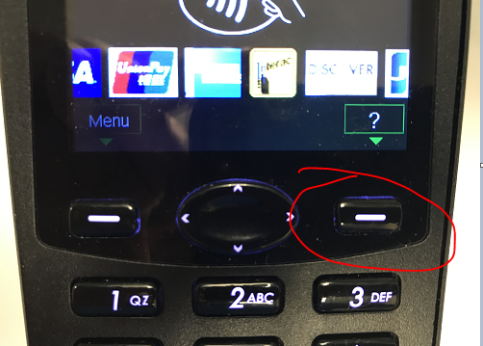

### 

*\*\*\*\*\*<HOSTIP>**204.092.075.201</HOSTIP>*

*<HOSTPORT>**33913</HOSTPORT>*

*<AUTH>Basic bm9pcmU6T2JKVGVVSlg=</AUTH> (Need to get user login/password from pinpad, (shows when booting up) and run it through* *<https://www.base64encode.org/> . Separate as user:password when entering into encoding site. Leave the word ‘basic’ in the line like example above.\*\*\*\*\**

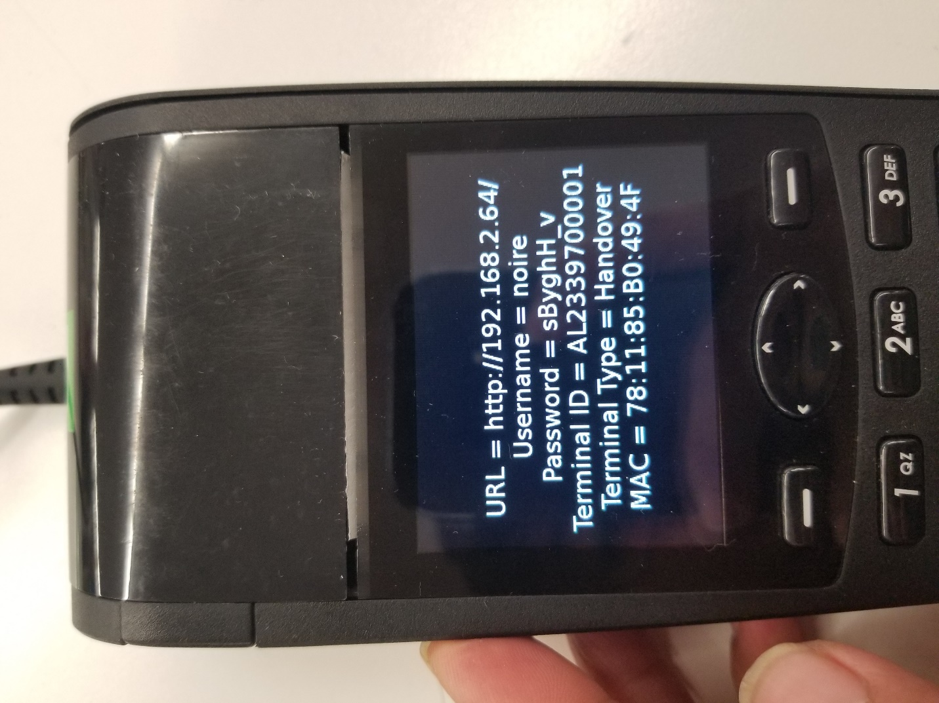

<NAVIP>71.19.161.154</NAVIP> *** NOT USED!

<NAVPORT>19921</NAVPORT> ****** NOT USED!

**For Pin-Pad Replacement**

1. Navigate to C:\Aralco\POS
2. Open PaymentProcessor.cfg
3. Look for the following:  
   **<TD>**

<REQUESTURL>[http://**10.187.140.172**/cgi-bin/</REQUESTURL](http://10.187.140.172/cgi-bin/%3c/REQUESTURL)>

**The IP Address in Green should be entered by the Payment Processor’s Tech team**

    <TERMINALID>N1000000AR01</TERMINALID>

    <HOSTIP>071.019.161.157</HOSTIP>

    <HOSTPORT>23519</HOSTPORT>

    <AUTH>Basic **bm9pcmU6T2JKVGVVSlg**=</AUTH>

See below for instructions how to obtain this AUTH Number then insert as shown above

    <NAVIP>71.19.161.154</NAVIP>

    <NAVPORT>19921</NAVPORT>  
</TD>

In most cases only REQUESTURL and **AUTH** will need to be changed, REQUESTURL is the IP of the pin pad, **AUTH** is Base64 encoded user:pass

1. To get**AUTH** in proper format go to <https://www.base64encode.org/> and enter user:pass, in this example it's "noire:ObJTeUJX", result is "**bm9pcmU6T2JKVGVVSlg=**"

See below example:

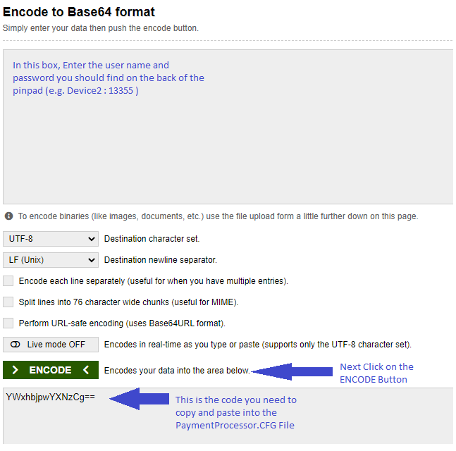

1. Make sure there is the word "Basic" before encoded credentials.
2. Restart POS
3. Go to POS>Setup>Pin pad Re-Initialize > Test Communications, click Initialize and check for a success message

# Aralco POS settings

### Settings

* In Aralco POS select **Setup » Software Options » Settings**;
* Enter a user login/password with privileges to enter this area;
* Expand **Bank Authorization**;
* Select **Card Type**;
* Select **510C**;

### Payment Methods

Each payment method that is being authorized through the pinpad needs to be setup. If all POS registers use the same setting, use Method A, if you have POS registers that are different and you **don’t want** the settings to be set on all registers use Method B.

##### Method A

* In Aralco Back Office select **POS » Tender Key Setup**;
* Enter a user login/password with privileges to enter this area;
* For each credit card and debit card that requires authorization through the pinpad the following fields should be selected:
  + Credit/debit card
  + Authorization

##### Method B

* In Aralco POS select **Setup » Software Options » Tender Key Setup**;
* Enter a user login/password with privileges to enter this area;
* For each credit card and debit card that requires authorization through the pinpad the following fields should be select:
  + Credit/debit card
  + Authorization

### License

* Customer must have a license for Card Authorization.

** Ports required open/forwarded on user network:

33913

33915

33917

33403

19620